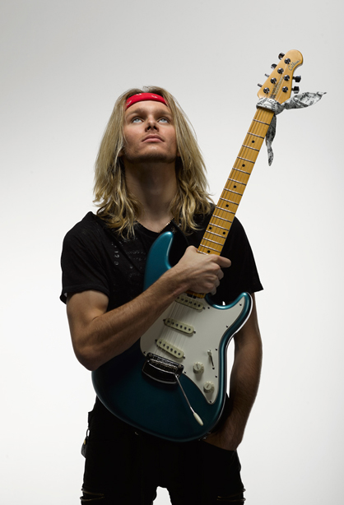
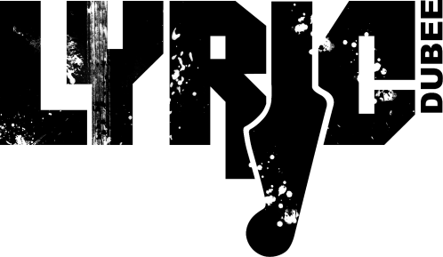
Lyric Dubee is an award winning, international touring, multi-genre artist born and raised in Barrie, ON. He is known for his own style of music labeled REVOLUTION ROCK which is a unique combination of ROCK, POP, BLUES, CLASSICAL, and JAZZ.

A singer, songwriter, and guitarist he performs his own works as a solo artist and fronts his own band.

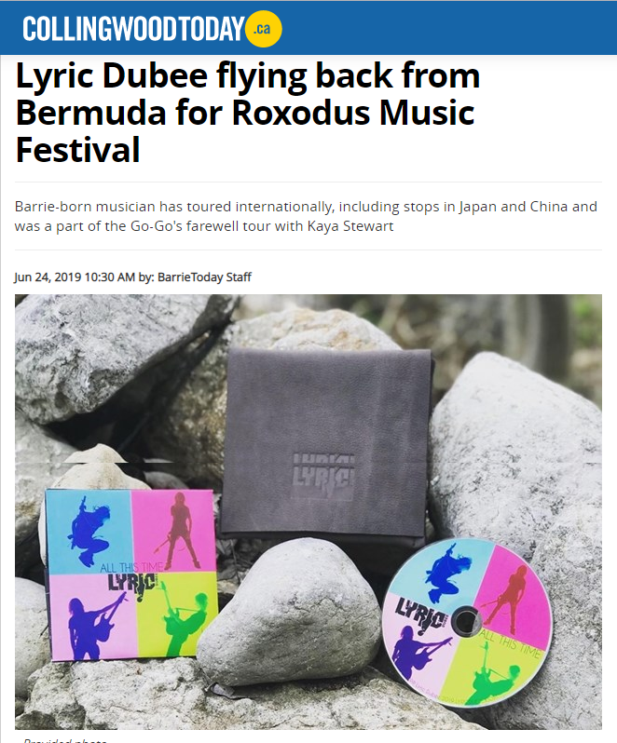
Lyric Dubee knew early on that music was going to be his life and by age 17 had released 4 albums which debuted on the rock and AC music charts. He studied classical and jazz guitar and recieved his Royal Conservatory certificate with honours while in grade school. He tours internationally and is endorsed by Ernie Ball MusicMan Guitars, DV Mark Amps, Guitar Center and is part of the Brotherhood of the Guitar. Now at age 21, he has released his 5th album ALL THIS TIME and decided to do his part in reducing plastic pollution by making the CD covers out of recycled material.

Live Performances Highlights
Lyric has opened for or shared the stage with legendary names such as Buddy Guy, Colin James, Rik Emmett (Triumph), Honeymoon Suite, Lee Aaron, Walk Off The Earth, David Usher, Blue Rodeo, and many more!
He has performed live over the last 9 years across the globe and in music festivals such as the Malibu Guitar Festival, IndieWeek, NXNE, CMW, Djangofest, SXSW, and headlined the Music By The Bay Festival.

International Performances include headlining the 2019 China Nanyang Music Festival for an audience of 10,000 fans, China and Japan “Young & Restless” Tour 2015, Los Angles, New York and the GoGo’s Farewell Tour with Kaya Stewart and a 4 month music residency in Bermuda.

THE MUSIC
Lyric’s music can be heard in regular rotation on various online and traditional radio stations and found on iTunes, Amazon, Soundcloud, Reverbnation, and Spotify. Many of his songs have charted including 2019 COME AROUND AGAIN which debuted at #2 on Q108 and reached #4 in the UK on Radio Indie Alliance. In 2018 CAN'T SAY NO placed in the top 5 on KB Radio Family of Indie Radio Stations. In 2015 LINGER debuted at #7 on the DRT National Airplay top 50 ROCK Charts and debuted at #21 on the National Airplay Top 80 Independent Artists Charts. COMBAT OF LOVE debuted at #11 on the US Top 20.FM Count Down in Hollywood California which Broadcast on over 500 Stations. 100 TO ZERO hit #2 on the National Air Play DRT Pop Top 20 Charts, and his single BLACK ICE was featured on Discover Hit Music.
AWARDS
Lyric has picked up multiple awards over the years including 2019 INTERNATIONAL ENTERTAINER OF THE YEAR (ISSA) as well as a finalist for the ISSA 2019 Male Single of the Year, Male Rising Star AND Male Vocalist of the Year. In 2018 Q108 Kingston included him in the top 5 male Canadian artists for his song THEY SAY.

"Lyric Dubee is a natural born star, he plays guitar like his life depended on it and sings his own songs with the sincerity needed to cut through a lot of today's manufactured music”.
DAVE STEWART
Eurhythmics

In 2015 he was a Unsigned Only Music Competition Semi-finalist for LINGER, WON Best Young Songwriter at the 2015 Toronto Independent Music Award for BRIDGE TO NOWHERE and BLACK ICE and WON Best Music Video for BLACK ICE at 2015 PLaYr York Region Film Festival
He also WON Honorable Mention with the song THEY SAY in the Teen category in the 2014 Unsigned Only Music Competition

In 2014 he was Semi-Finalist for BRIDGE TO NOWHERE in the International Songwriting Competition, and WON Best Music Video for ALIVE at 2014 York Region Film Festival as well as WINNING Most Promising Youth Award at 2014 Barrie Arts Awards

In 2011 Lyric WON Best Young Songwriter Award at the Barrie New Music Festival and his album BROKEN DREAMS was used as a soundtrack for Rogers TV “New Slang” show

Press and Reviews
Lyric has been featured and interviewed in various media outlets including CBC, CP24 Breakfast TV, Rogers Daytime, SIRIUS Radio and the Humble and Fred Show and has had many articles written about him including being featured in Guitar International Magazine 2015 and 2019.

ALL THIS TIME ALBUM REVIEWS:

“FUNKIFIED BLUESIFIED SOULIFIED & ROCKIFIED. Really shows diversity and growth as an artist.”
Randy Skaggs- Q108

“Will be adding the new tune to our master playlist! I love the video for “Back Home” – makes me dance in my seat!! ”
Bootsy Hambone-KKID 92.9 fm

“Did you ever just have the feeling you were in the company of greatness? For instance, I wonder what the people in Elvis's high school thought when they first heard him sing. Chills right? Well that’s what I got when I first heard and then saw Lyric Dubee.”
JOHN REIGN – CRANK IT UP MAGAZINE, USA 2016

“Dubee could well be the next Jon Bon Jovi: equally at home and confident writing his own songs, composing with others, and performing in various genres like the seasoned entertainer that he already is. It’s when he steps out of his comfort zone, however, that he truly lets his genius bloom.”
LAURIER TIERNAN – METROPOLIS MAGAZINE, Japan

“Teen’s music beyond his years”
DANIELLE VANDENBRINK,
KINGSTON WHIG-STANDARD

