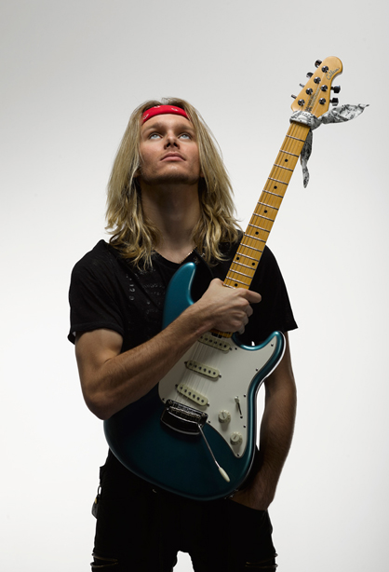
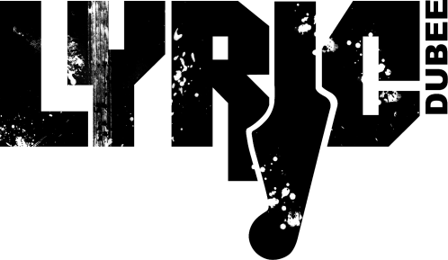
Lyric Dubee is an award winning, international touring, multi-genre artist born and raised in Barrie, ON. He is known for his own style of music labeled REVOLUTION ROCK, which is a unique combination of ROCK, POP, BLUES, CLASSICAL, and JAZZ.

A singer, songwriter, and guitarist he performs his own works as a solo artist and fronts his own band.

Lyric Dubee knew early on that music was going to be his life and by age 17 had released 4 albums which debuted on the rock and AC music charts. He tours internationally and is endorsed by Ernie Ball MusicMan Guitars, DV Mark Amps, Guitar Center and is part of the Brotherhood of the Guitar. Now at age 21 he has released his 5th album ALL THIS TIME and is the winner of the 2019 ISSA INTERNATIONAL ENTERTAINER OF THE YEAR.

"Lyric Dubee is a natural born star, he plays guitar like his life depended on it and sings his own songs with the sincerity needed to cut through a lot of today's manufactured music”.
DAVE STEWART
Eurhythmics

Live Performances Highlights
Lyric has opened for or shared the stage with legendary names such as Buddy Guy, Colin James, Rik Emmett (Triumph), Honeymoon Suite, Lee Aaron, Walk Off The Earth, David Usher, Blue Rodeo, Steve Ferone (Tom Petty), Richie Sambora (Bon Jovi), Carole Pope (Rough Trade) and many more talented musicians.
He has performed live over the last 9 years across the globe and in music festivals such as the Malibu Guitar Festival, IndieWeek, NXNE, CMW, Djangofest, SXSW, and headlined the Music By The Bay Festival. Lyric just returned from a 4 month music residency in Bermuda performing 5 nights a week.

International Performances include headlining the 2019 China Nanyang Music Festival for an audience of 10,000 fans, China and Japan “Young & Restless” Tour 2015, Los Angles, New York and the GoGo’s Farewell Tour with Kaya Stewart.
THE MUSIC
Lyric’s music can be heard in regular rotation on various online and traditional radio stations and found on iTunes, Amazon, Soundcloud, Reverbnation, and Spotify.
Album review
“FUNKIFIED BLUESIFIED SOULIFIED & ROCKIFIED. Really shows diversity and growth as an artist.”

Randy Skaggs- Q108

“Will be adding the new tune to our master playlist! I love the video for “Back Home” – makes me dance in my seat!! ”

Bootsy Hambone-KKID 92.9 fm
ALL THIS TIME 2019
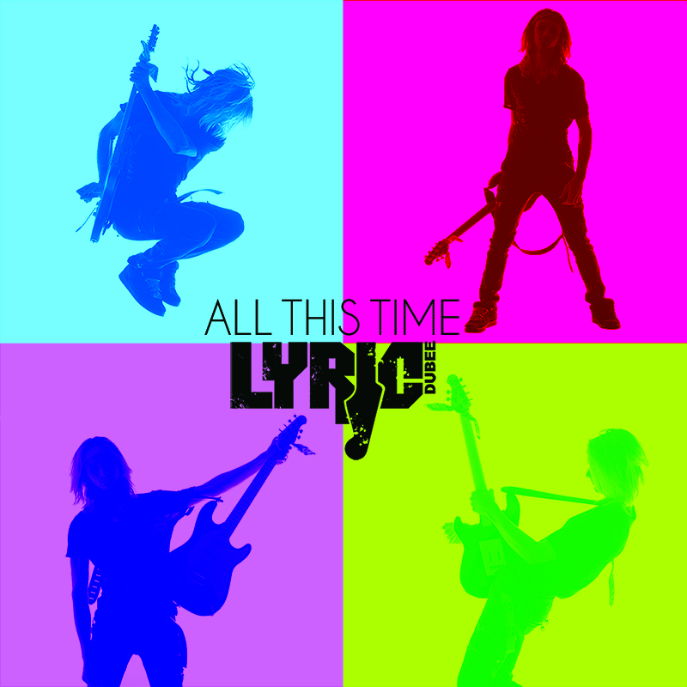
Lyric’s diversity shines through on this CD as he stays true to his musical genre by drawing influence from the musical styles he has studied. You will hear a range of Funk & Rock to Blues & Pop.

• 2019 ISSA Male Single of the Year Finalist for COME AROUND AGAIN along with finalist for Male Rising Star and Male Vocalist of the Year
• CAN'T SAY NO in the top 5 on KB Radio Family of Stations
• COME AROUND AGAIN Debuts at #2 on Q108
• COME AROUND AGAIN reaches #4 in the UK on Radio Indie Alliance

COMBAT OF LOVE 2015
At 17 Lyric released his 4th album which he wrote and recorded in LA with Grammy Award Winning Producer Warren Huart (Aerosmith, The Fray, James Blunt).
Album review
“I like this “Combat Of Love!” … It has some damned good guitar work + lyrics set to what I would call a semi – rock beat! … Pleasing to the ear & containing just enough emotion to keep you coming back for another listen! … Can’t wait to hear some more of this guy’s work!”
COUNT, MUSIC DIRECTOR AT WAYOUTRADIO.CO.UK

• 2015 Semi-finalist Unsigned Only Music Competition for LINGER
• LINGER debuted at #7 on the DRT National Airplay top 50 ROCK Charts

• COMBAT OF LOVE debuted at #11 on the US Top 20.FM Count Down in Hollywood California “The World’s NB1 Weekly Top 20 Countdown Show | Broadcast On Over 500 Stations”

• LINGER also debuted at #21 on the National Airplay Top 80 Independent Artists Charts
BLACK ICE 2015
Lyric started recording his 3rd album in February 2014 and recorded all 10 songs between Nashville and Toronto. The album was released on Sept 19 2015 along with his 4th album Combat of Love
• “100 To Zero” hit #2 on the National Air Play DRT Pop Top 20 Charts
Album review
“Lyric continues to outdo himself with each and every song. He is a lot like Eric Clapton, you never know what is coming, but when it gets there it blows you away… He is going to become a legend.”
TOMMY NEAL – STARS2COME.COM (2014 Black Ice Single Review)

• WON Best Young Songwriter at the 2015 Toronto Independent Music Award for BRIDGE TO NOWHERE and BLACK ICE
• WON Best Music Video for BLACK ICE at 2015 PLaYr York Region Film Festival
• Song Feature for BLACK ICE featured on Discover Hit Music
• WON Honorable Mention with the song THEY SAY in the Teen category in the 2014 Unsigned Only Music Competition

• Semi-Finalist for BRIDGE TO NOWHERE at 2014 International Songwriting Competition
• Q108 Kingston top 5 male Canadian artists for THEY SAY

ALIVE 2012
Album review
“Like his Debut album this new CD (ALIVE) is another gem that must be heard! Each track is a masterpiece that truly demonstrates just how talented young Lyric is in his writing and arrangement skills. In addition to this, Lyric’s vocals are now more mature as his vocals have dropped dramatically.”
ROD JOHNSON, RIVENMASTER.COM
Lyric wrote all the songs for his 2nd album and released it at age 14 to rave reviews and international sales.

• WON Best Music Video for ALIVE at 2014 York Region Film Festival
• WON Most Promising Youth Award at 2014 Barrie Arts Awards

BROKEN DREAMS 2011
Lyric wrote all the songs for his debut album which he released when he was just 12 years old.
Album review
“Teen’s music beyond his years”
DANIELLE VANDENBRINK,
KINGSTON WHIG-STANDARD

• WON Best Young Songwriter Award at the 2011Barrie New Music Festival
• BROKEN DREAMS album was used as a soundtrack for Rogers TV “New Slang” show
Press and Reviews
Lyric has been featured and interviewed in various media outlets including CBC, CP24 Breakfast TV, Rogers Daytime, SIRIUS Radio and the Humble and Fred Show and has had many articles written about him including being featured in Guitar International Magazine 2015 and again in 2019.

He was also featured as 1 of 4 up and coming new artists in an art gallery at the Delano Vegas Hotel - Rock ‘n’ Roll legends and Emerging Music Talent, “Defiantly Inspired” with the likes of “Slash” & “Carlos Santana”.

“Definitely a star! And the hardest working artist I know.” ELAINE OVERHOLT – vocal coach to the stars (John Travolta, Michelle Pfeiffer, Richard Gere, Catherine Zeta-Jones, Renée Zellweger, Queen Latifah)
“Canada over the years has brought about some great superstars of music, like Shania Twain and Justin Bieber. Now we have another great artist coming from Canada, and he has the ability to be the greatest yet. Lyric Dubee will be, “Canada”s Newest Superstar”!”
TOMMY NEAL – STARS2COME.COM

“Did you ever just have the feeling you were in the company of greatness? For instance, I wonder what the people in Elvis's high school thought when they first heard him sing. Chills right? Well that’s what I got when I first heard and then saw Lyric Dubee.”
JOHN REIGN – CRANK IT UP MAGAZINE, USA 2016

“Lyric Dubee is the real deal. I love this young man’s talent, work ethic and current song list which is light years beyond everything I heard!. He has the song writing ability of Taylor Swift and a young Bryan Adams combined with the youthfulness of Justin Beiber and the guitar playing and blues knowledge of Colin James. He is the embodiment of the future of music in Canada.”
MICHAEL WILLIAMS – JOURNALIST, RECORD PRODUCER & MEDIA PERSONALITY

“I have never seen anyone so young sound so great, original and musically sophisticated. Both albums are really great” T.M. STEVENS reviewing Broken Dreams & Alive Albums -
Bassist for The Pretenders & recorded with Steve Vai, Cyndi Lauper, Tina Turner, and Billy Joel

Fun Facts about Lyric
links

Website

YouTube

Facebook

Instagram

Twitter

• He loves animals!
• He loves physical fitness and is a 2nd degree black belt in TKD.
• Lyric loves to work with children and spent a few years volunteering at a local elementary school teaching music and encouraging youth to embrace the arts.
• Lyric spent most of his younger years dabbling in modeling, acting, dance, theatre and gymnastics. Performing has always been his one true love.
• He studied classical guitar, jazz guitar and music theory. He passed his final Royal Conservatory of music classical guitar exam with “Honours ” and he received ” First Class Honours ” on his last theory exam.
• Inducted into the Brotherhood of the Guitar in 2014.

“Dubee could well be the next Jon Bon Jovi: equally at home and confident writing his own songs, composing with others, and performing in various genres like the seasoned entertainer that he already is. It’s when he steps out of his comfort zone, however, that he truly lets his genius bloom.”
LAURIER TIERNAN – METROPOLIS MAGAZINE, Japan

